**Lesson 5 Demo 4**

**Understanding Rollbacks**



Steps to be followed:

1. Checking the rollout history
2. Rolling back to a specific version

**Step 1: Checking the rollout history**

1. Write the following command to check out the rollout history:

***kubectl rollout history daemonset fluentd-elasticsearch -n kube-system***

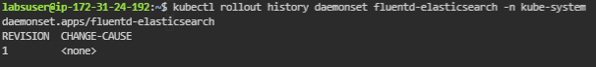

**Step 2: Rolling back to a specific version**

1. Write the following command to check out the rollout history:

***kubectl rollout undo daemonset fluentd-elasticsearch -n kube-system --to-revision=1***



| **Note:** Here we have only one version so the message shows it matches the revision version. |
| --- |